PROJECT REPORT

OF

BUSINESS ANALYTICS



“Coffee Shop Sales Dashboard Analysis”

A PROJECT REPORT

Submitted by:

NAME OF THE CANDIDATE:

DEEPAK KUMAR(23MCA20605)

In partial fulfillment for the award of the degree of

MASTER OF COMPUĽER APPLICATION

(M.C.A)

IN

UNIVERSITY INSTITUTE OF

COMPUTING DEPARTMENT OF

COMPUTER SCIENCE



Chandigarh University

Academic Session: 2023-2025

3



BONAFIDE CERTIFICATE

Certificate that this project report “Coffee Shop Sales Dashboard Analysis” is

the bonafide work of “DEEPAK KUMAR (23MCA20605)”who carried out the project work under my/our suprvision.

SIGNATURE SIGNATURE

Dr. Abdullah SWETA

(HOD) (SUPERVISOR)

Submitted for the project viva-voce examination held on

INTERNAL EXAMINER EXTERNAL EXAMINER

## TABLE OF CONTENT

1. Introduction

1. Objective

1. Dataset Overview

1. Data Cleaning and Preparation

1. Dashboard Design

* Key Metrics
* Charts and Visualizations

6.Analysis of Results

* Insights
* Trends
* Recommendations

7.Conclusion

8. Uploading the project on the GIT HUB

INTRODUCTION

In today’s competitive landscape, understanding customer preferences and monitoring sales performance in real-time is vital for the growth of businesses, especially in the food and beverage industry. This project focuses on creating an interactive Excel dashboard that visually presents key sales data from a coffee shop. With this tool, managers and business owners can gain insights into customer behavior, sales trends, and product performance, enabling them to make data-driven decisions.

The coffee shop dataset covers transactions across multiple months and includes information on products, revenues, and payment methods. The dashboard allows stakeholders to assess sales trends and make informed decisions to optimize inventory, sales promotions, and overall operations.

2.Objectives:

The core objectives of the coffee shop sales dashboard project are as follows:

* Visualize and analyze sales data in an intuitive manner using an Excel dashboard.
* Identify top-selling products and customer preferences across different time periods.
* Track performance trends in sales revenue, units sold, and payment methods.
* Enable decision-makers to make real-time adjustments by offering insights into peak sales times, slow periods, and preferred payment methods.
* Provide actionable recommendations based on the analyzed data to improve business operations and increase revenue.

3.Dataset Overview

The dataset utilized in this project includes the following key variables:

* + Date: The exact date and time of each transaction.
  + Product: The name of the coffee or food item sold (e.g., Espresso, Latte, Muffin).
  + Quantity: Number of units sold per transaction.
  + Revenue: The total revenue generated from the transaction.
  + Payment Method: The mode of payment used by the customer (e.g., Cash, Credit, Mobile Payment).

Dataset Characteristics:

* + Time Frame: The dataset spans 6 months, from January to June 2024.
  + Records: The dataset contains over 5,000 individual sales records.
  + Product Range: The coffee shop offers a wide range of products, including various coffee types (e.g., Espresso, Cappuccino), food items (e.g., Muffins, Croissants), and seasonal specials.

Data Types:

* + Numeric Data: Revenue and Quantity columns.
  + Categorical Data: Product types and Payment Methods.
  + Temporal Data: Dates and times of each transaction.

The dataset provides a rich source of information to identify trends and key metrics relevant to the coffee shop's performance.

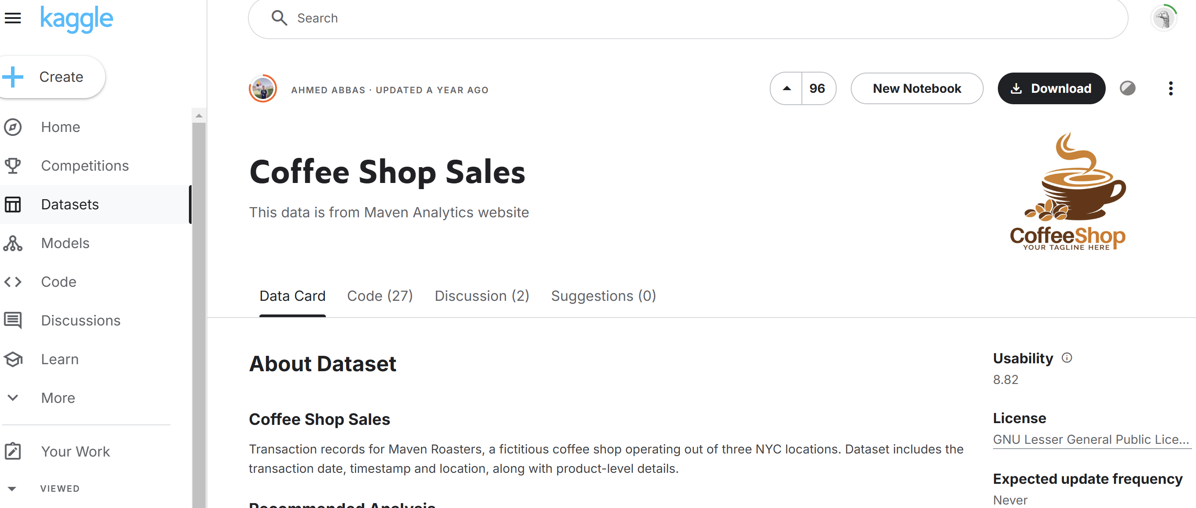

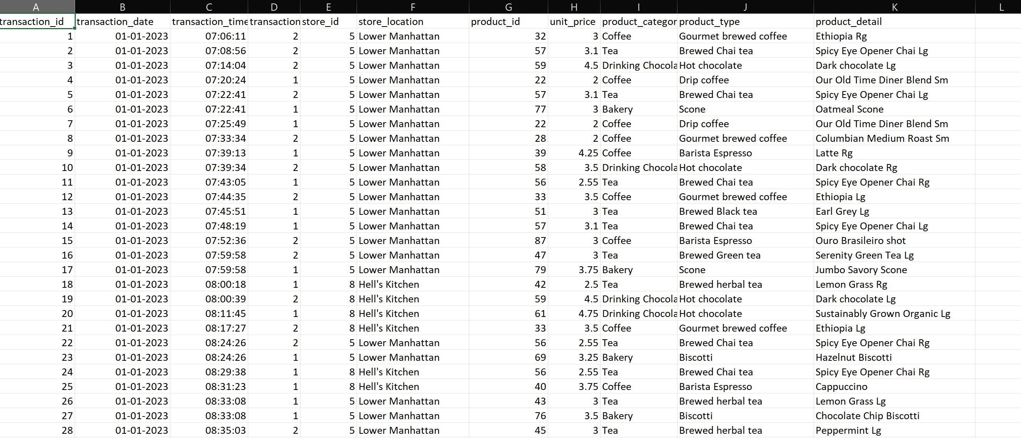

4.Data Cleaning and Preparation

Before building the dashboard, the dataset underwent significant cleaning and preparation to ensure accuracy and usability. Below is a detailed breakdown of the data cleaning process:

1. Missing Values:
   * Revenue & Quantity: Some rows had missing values in the revenue or quantity columns. These were filled using median values specific to the product categories.
2. Duplicate Removal:
   * Duplicates: Multiple instances of duplicate transactions were found, especially in cases where customers were charged twice for the same order. These duplicate rows were identified and removed to avoid inflating the sales data.
3. Formatting Consistency:
   * Dates: The date and time fields were reformatted for consistency. Excel’s date format was used to ensure easy manipulation in pivot tables and charts.
   * Product Naming: Inconsistent product names (e.g., "Latte" vs "latte") were standardized to avoid errors in analysis.
4. Outlier Handling:
   * Outlier Detection: Certain transactions had unusually high or low revenues, likely due to data entry errors. These outliers were investigated and corrected or removed as necessary.
5. Data Validation:
   * Logical Consistency: Checks were applied to ensure that no negative quantities or revenue values existed in the dataset.

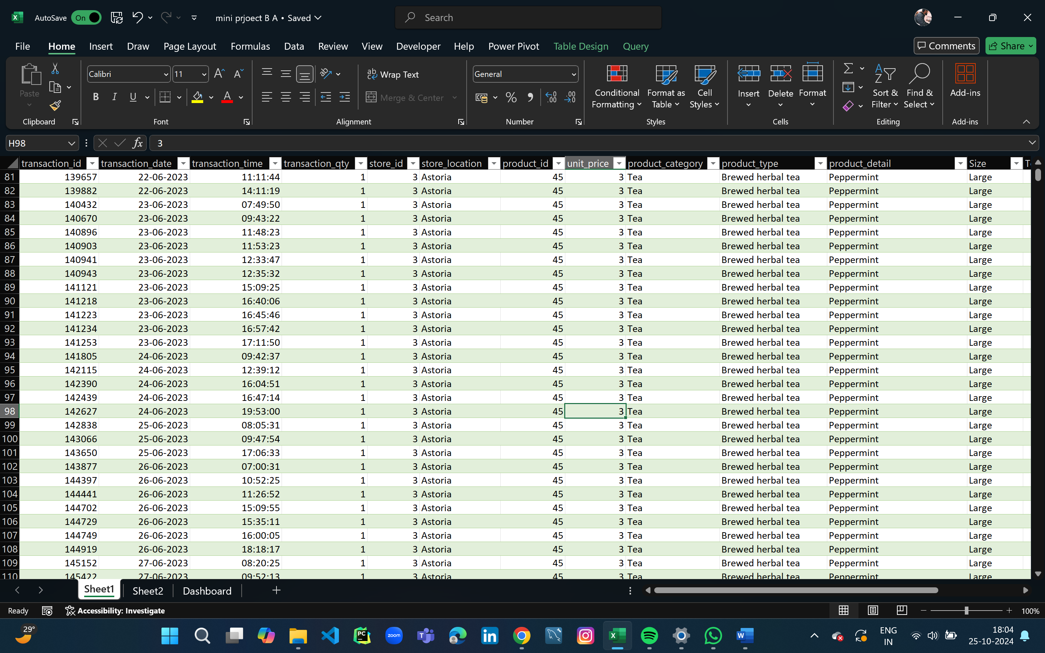

These preprocessing steps ensured that the dataset was clean, consistent, and ready for analysis.

PIVOT TABLE

A **pivot table** is an essential data analysis tool that enables dynamic summarization of large datasets in just a few clicks. It’s perfect for a mini-project aimed at uncovering insights from complex data, making it easy to see trends, totals, and averages across multiple categories.

**Key Components:**

* **Rows**: Groups data vertically by category (e.g., Product Category).
* **Columns**: Adds another layer horizontally (e.g., Year).
* **Values**: Aggregates data (Sum, Average, Count) for each row-column pairing.
* **Filters**: Narrows down data (e.g., Region) for refined insights.

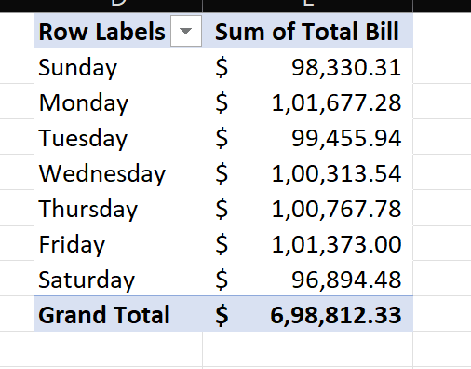 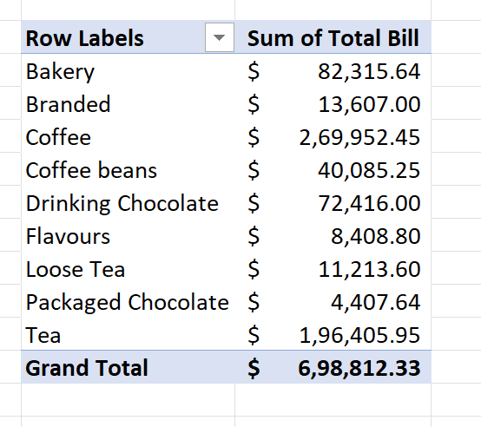

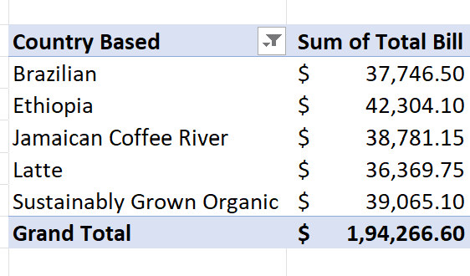 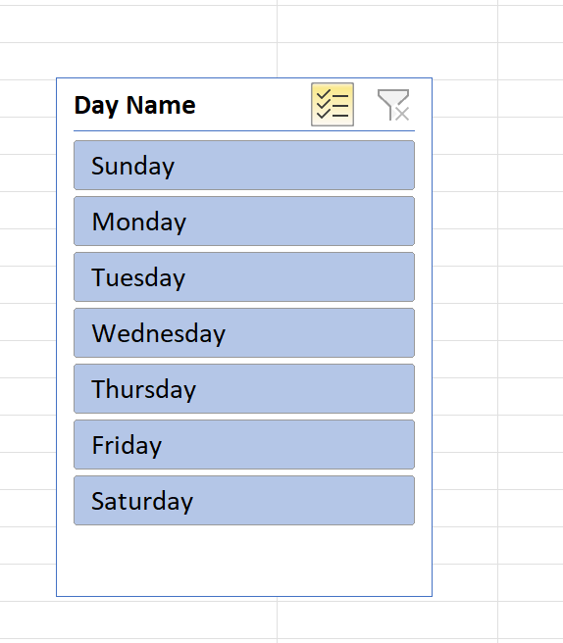

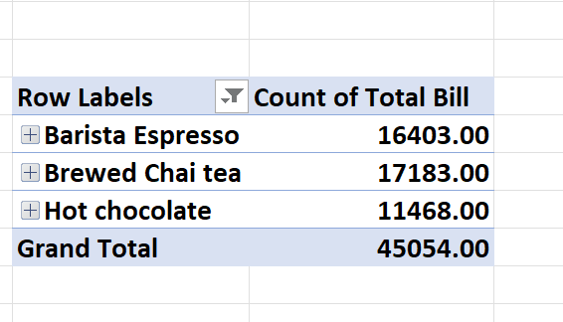 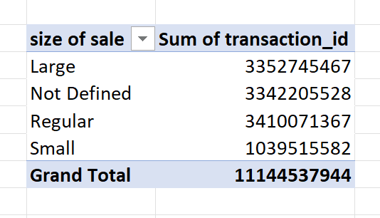

1. Dashboard Design

The Excel dashboard was designed with both functionality and aesthetics in mind, making it easy to understand and use. The dashboard includes several visual elements that display key performance indicators (KPIs) and offer the flexibility to filter data.

Key Metrics Displayed:

* 1. Total Sales Revenue: A snapshot of the overall revenue generated during the selected time period.
  2. Total Units Sold: The total number of coffee and food items sold.
  3. Top 5 Products: A list of the best-selling items, ranked by units sold.
  4. Revenue by Payment Method: A breakdown of sales by payment method (e.g., Credit Card, Cash, Mobile Payment).
  5. Daily Sales Trends: A line chart showing daily fluctuations in sales revenue and units sold.

Charts and Visualizations:

* 1. Pie Chart:
     + Displays the contribution of each product category (e.g., coffee types, food items) to total sales revenue. o Helps visualize which categories are the most popular and drive the most revenue.
  2. Bar Chart:
     + Compares individual products by units sold. The bar chart helps identify the most popular and least popular items in the menu.
  3. Line Chart:
     + Visualizes sales trends over time, highlighting peaks and dips in revenue and quantity sold. This chart offers insights into seasonal patterns and high-demand periods.
  4. Stacked Column Chart:
     + Breaks down total revenue by payment method, allowing the management to see which payment methods are most commonly used.

Interactive Features:

1. Slicers:

* + - Added slicers for Date Range, Product, and Payment Method. These slicers enable users to dynamically filter the data and view the performance of specific products or analyze sales for a particular time period.

2. Dropdown Menus:

* + - Dropdown filters allow users to switch between different sales metrics (e.g., revenue vs. quantity sold) to focus on specific areas of interest.

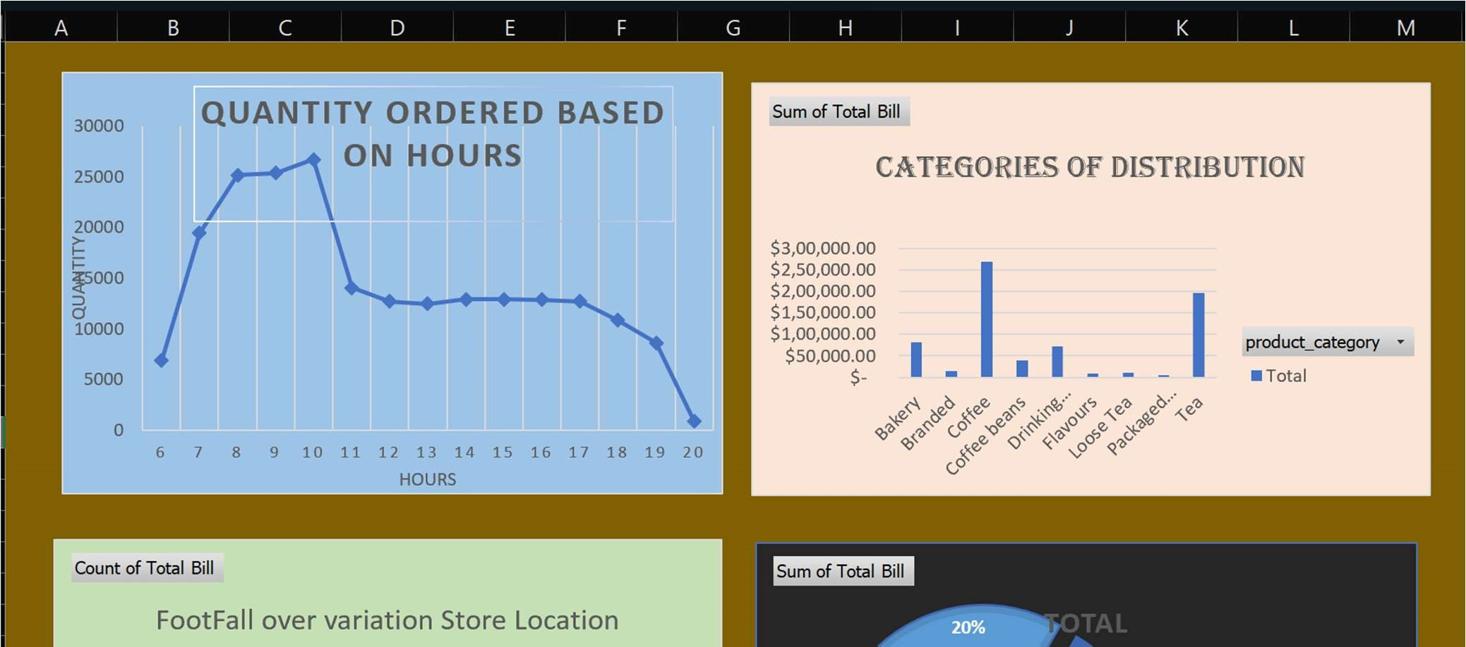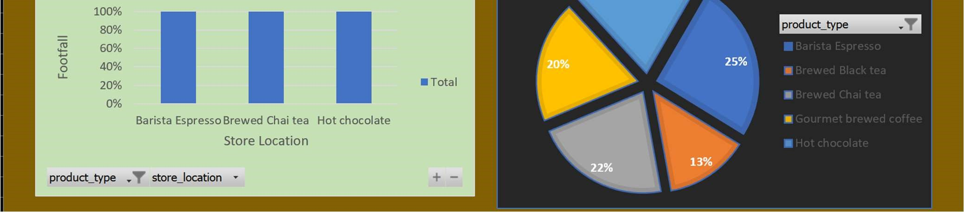

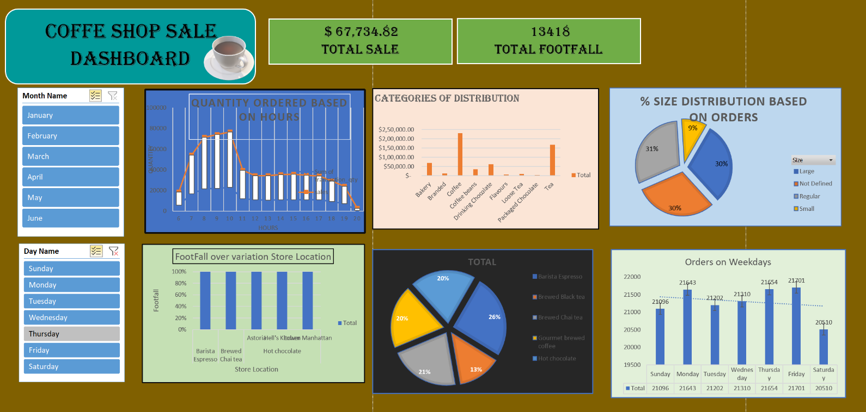

* 1. Best-Selling Products:
     + Cappuccino and Espresso are the top-selling products, contributing nearly 40% of total sales revenue. These items consistently perform well, regardless of the season.

* 1. Sales by Payment Method:
     + Credit Card payments dominate, accounting for 65% of transactions, while cash payments have decreased, indicating a shift toward digital payment methods.
  2. Peak Sales Hours:
     + The busiest sales hours are between 9 AM and 11 AM, likely driven by the morning coffee rush. This period accounts for nearly 35% of daily sales.

Detailed Trends:

1. Monthly Trends:

* + - Sales dip slightly in July, possibly due to vacation periods, but pick up again in September as customers return to their routines. Summer months show a higher demand for cold beverages like iced coffee.

2. Customer Preferences:

* + - There is a noticeable preference for specialty drinks during colder months, with higher sales of items like hot chocolate and lattes.

Business Recommendations:

1. Increase Inventory for High-Demand Items:

* + - Based on consistent sales, it is recommended to maintain a higher inventory of ingredients for Cappuccinos and Espressos, especially during peak hours.

2. Focus on Digital Payment Methods:

* + - With the rise in credit card and mobile payments, the coffee shop could consider offering special promotions or discounts for digital payments to encourage faster transactions and reduce handling of cash.

3. Seasonal Promotions:

* + - Introduce promotional offers, such as discounts or loyalty rewards, during offpeak months (e.g., July) to encourage more customer traffic.

1. Conclusion

The coffee shop sales dashboard offers a clear and actionable view of the shop's performance over a six-month period. The insights derived from the data can guide the business in making more informed decisions, whether it’s about inventory management, promotional strategies, or customer engagement.